Newtown Astronomy Society always welcomes new members!

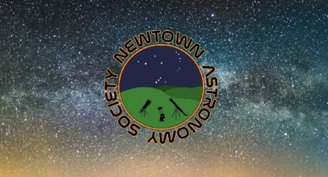

Supported by Newtown and Llanllwchaiarn Town Council

Membership runs for 12 months from date of joining or renewal.
Fees are £25 per adult giving free entry to our monthly meetings, September to June
Entry for adult non-member ie guest fee is £4
Under 18s can become members and attend free but cannot stand as Committee members. They must be accompanied and signed in by an adult who is, or has permission or, the parent/guardian, and is also a member or paying guest

Please complete a separate form for each member; one payment for multiple memberships
Please complete all sections in BLOCK CAPITALS

If paying by cheque please return your completed form with your cheque to:

Ray Dent
Honorary Treasurer
Lluest Isaf
Carno
Caersws
Powys
SY17 5LX

Please do not send cash

If paying by BACS, please use the following details:

Account Name: Newtown Astronomy Society
Sort code: 51-61-06
A/c no: 76824934

Please add your name in the ‘your reference’ box to identify your payment
Then e-mail the completed form to: secretary.newtownastrosoc@gmail.com
For information

Membership rules:

- Membership is an expression of interest in and support for the aims and objectives of Newtown Astronomy Society
- Membership gives free entry to our monthly in-person meetings (refreshments are chargeable) and Zoom meetings
- Membership allows the right to attend, take part in, and vote at the Annual General Meeting

If you have any further queries please do not hesitate to contact us at:

secretary.newtownastrosoc@gmail.com

Change of contact details

Please advise the NAS secretary if you change any of your contact details to ensure that you receive any correspondence and notifications. It is particularly important we have an up-to-date telephone contact number in case of last minute cancellation of any event.

Membership cancellation

If you wish to cancel your membership, please e-mail secretary.newtownastrosoc@gmail.com with your request. Reasons for cancelling would be appreciated to enable the Society to ensure it continues to provide the content its membership wants. Please note that any remaining membership fees will not be refunded.

Data protection

The details you have provided are for NAS Committee use ONLY and will be held in compliance with the General Data Protection Regulations (GDPR)

- Full name *

- Full address including postcode *

- Phone number *
Home:

Mobile:

- E-mail address in case sensitive letters

- Type of membership *

New Renewal

- Payment type *

BACS

Cheque – please put name and address on back of cheque

- Are you on Facebook?

Yes No

- What name will you be joining any Zoom meetings under?

- Voluntary donation included? Amount

NAS USE ONLY

Member’s name:

Paid amount £ Date

Method of payment

BACS
Cheque Number Banked on
Cash

Membership number:

Forwarded to Secretary

